CURRICULUM VITAE
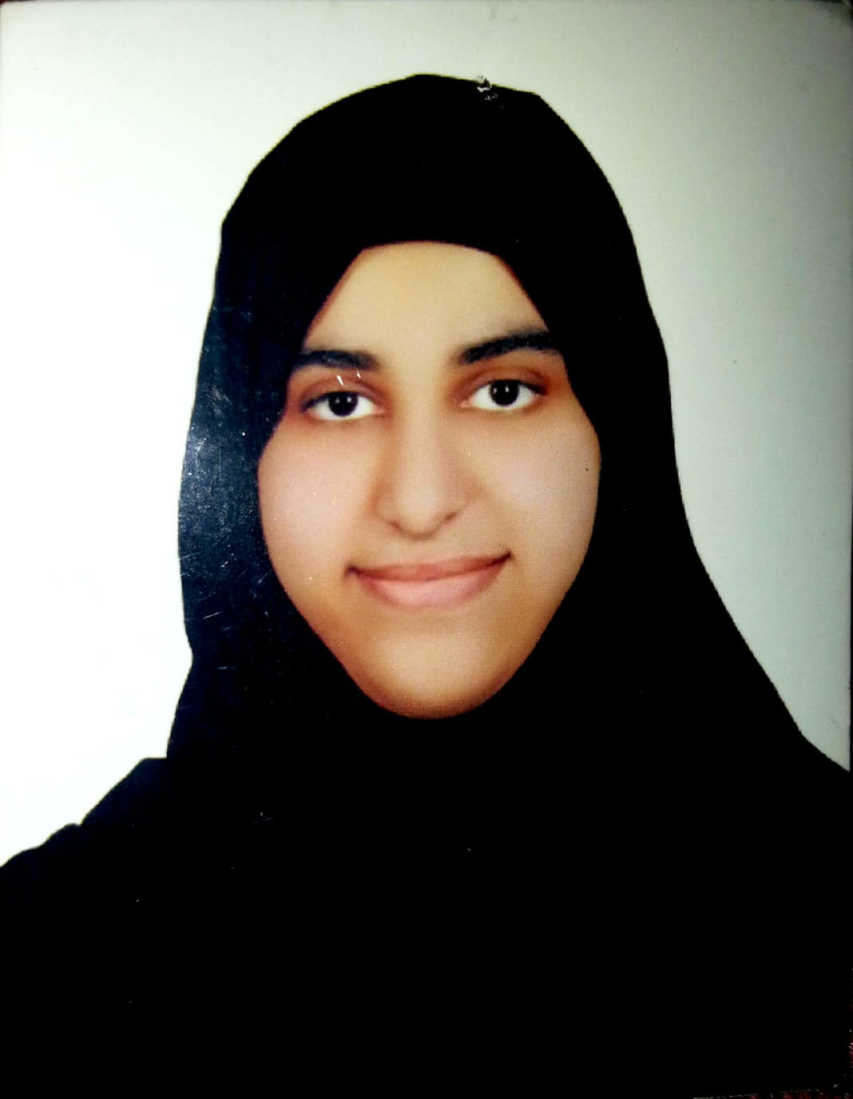

Name: Khadija Isa Ahmed Isa AL.Shaikh
Date of Birth: 8/8/1996
Nationality: Bahraini
Religion: Muslim
Marital Status: Single
Address: House No.: 109, Road: 3306, Dair: 233, Muharraq.
Contact No.: Mobile: 38759290
E-mail Address: khadijaalshaikh66@gmail.com
CPR: 960802240
Passport No.: 2614249

Educational Background: -
Organization Qualification Year
Muharraq Secondary Girls School Scientific Secondary Certificate 2014
Injaz Bahrain Job Shadow Program 2012-2013

Experience:-
Job Place Period
Sales Edu quick one month from
Customer services Edu quick 14/2/2019 to
Call center Edu quick 16/3/2019
Special Interest:-
Mathmatics,Chemistry,Physics,Computer

Language:-
Arabic, English – Spoken & Written.

